**National University of Computer and Emerging Sciences**



**Project Report**

*For*

**Data Structures**

**Title: WhatsApp Chat Analyzer**

**Members:**

**Mushahid Hussain 18K-0280**

**Osama 18K-0334**

**Mubashir 18K-1053**

**Overview**

WhatsApp has a feature to export conversation between two people as a text file. WhatsApp Chat Analyzer takes the text file as an input and outputs the topic of conversation based on words used in the conversation.

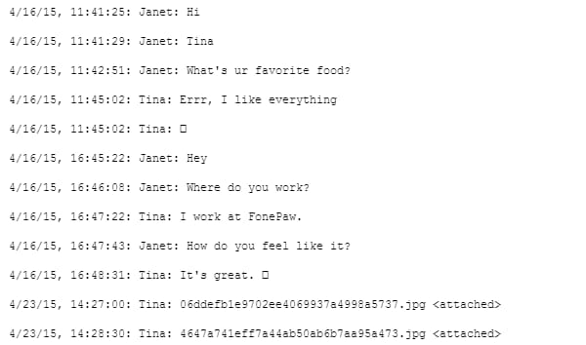

**Working details**

We will maintain a list of topics and a list of words for every topic in the list. Conversation topics can be, family, academic, career, business, financial, friend, relationship. There would be a list of possible words, which are frequently used in such conversations. For example an academic conversation can have frequent words like ‘assignment’, ‘thesis’, ‘essay’, ‘scientific paper’ etc. Our project would search for these words in the text document using efficient searching algorithms and data structures and output possible topic of the conversation. Furthermore, project can be expanded to provide statistics for the conversation i.e number of words typed in the conversation on a specific day, average words typed by the user etc.

**Data Structures**

Data structures to be used are but not limited to Binary Trees, Stack, and Queues.

**Libraries Used**

#include "mainwindow.h"

#include "ui_mainwindow.h"

#include "mainwindow.h"

#include "ui_mainwindow.h"

#include<iostream>

#include<string>

#include<QMessageBox>

#include<QFile>

#include<QTextStream>

#include<stack>

#include<QStringList>

#include <bits/stdc++.h>

#include <iostream>

#include <sstream> // for string streams

#include <string> // for string

**Sample Output**